

VIETNAMESE STUDY SYSTEM FOR JAPANESE

Screen Design

**Project Code: Veazy**

**Document Code: Veazy_ Screen_Design_v1.1_EN**

**Ha Noi, 06/10/2016**

Record of change

*A - Added M - Modified D – Deleted

|  |  |  |  |  |
| --- | --- | --- | --- | --- |
| **Effective Date** | **Changed Items** | **A* M, D** | **Change Description** | **New Version** |
| 06/10/2016 | Screen design | A | Add screens | v1.0 |
| 06/30/2016 | Screen design | M | Update screens | v1.1 |
| 07/05/2016 | Screen design | A, M | Add & upddate screens | v1.2 |

Table 1. Records of changes

**Signature page**

**Originator** Nguyen Hong Quan 05/08/2014

Developer

**Reviewer** Nguyen Trong Duy 06/08/2014

Developer

**Approval** Nguyen Van Sang 06/08/2014

Supervisor

Table of Contents

1 Introduction 6

1.1 Purpose 6

1.2 Definitions, Acronyms and Abbreviations 6

1.3 Overview 6

2 Screen Flow 7

2.1 Guest 8

2.1.1 Homepage 8

2.1.2 Login 10

2.1.3 Recovering Password 12

2.1.4 Register 13

2.1.5 Course 14

2.1.6 Lesson Detail 15

2.1.7 Test 17

2.1.8 Article List 18

2.1.9 Article Detail 19

2.2 Logged-in user 20

2.2.1 User Profile 20

2.2.2 Test Statistics 21

2.3 Content creator 22

2.3.1 Content Creator Dashboard 22

2.3.2 Lesson List 24

2.3.3 Lesson Detail 24

2.3.4 Adding Lesson 24

2.3.5 Editing Lesson 27

2.3.6 Question List 27

2.3.7 Question Detail 28

2.3.8 Adding question 29

2.3.9 Editing Question 34

2.4 Content manager 39

2.5 Admin 39

2.5.1 Admin Dashboard 39

2.5.2 Member List 40

2.5.3 Report List 41

3 Other considerations 42

# Introduction

## Purpose

The purpose of this document is to ensure the consistency as well as the simplicity in detailed design across all displays within Veazy interface. Screen design describes the process of designing layout and appearance of Veazy web page so that it is engaging to readers and easy to use.

## Definitions, Acronyms and Abbreviations

|  |  |  |
| --- | --- | --- |
| Abbreviations | Description | Comment |
| Veazy | Vietnamese Study System for Japanese |  |
| Q&A | Question and Answer |  |

Table 2. Acronyms & Abbreviations

## Overview

Image of web page here

# Screen Flow

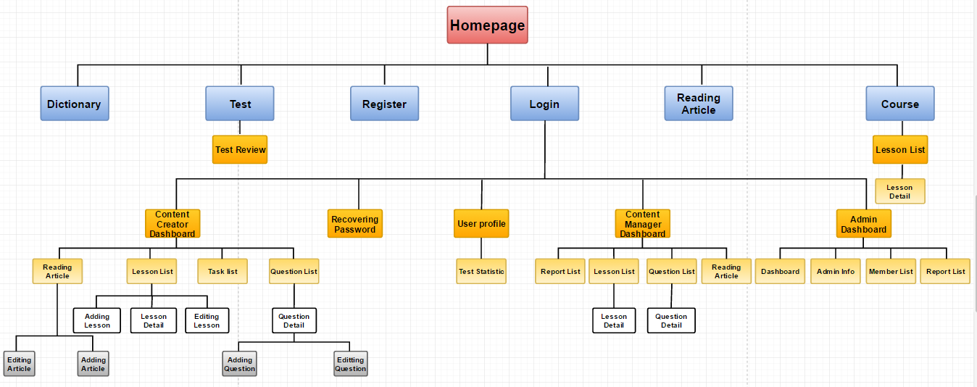

Figure 1. Screen Flow

|  |  |  |
| --- | --- | --- |
| No | Screen Name | Description |
| 1 | Homepage | Homepage |
| 2 | Login | Logging into Veazy system with a registered account |
| 3 | Register | Registering new account |
| 4 | Recovering Password | Recovering lost password |
| 5 | Courses | Displaying list of courses and available lessons in each course |
| 6 | Lesson Detail | Displaying lesson content |
| 7 | Test | Setting up and doing test |
| 8 | Article List | Displaying article list |
| 9 | Article Detail | Displaying article content |
| 11 | User Profile | Displaying detailed information of user |
| 12 | Test Statistics | Displaying statistics assessed based on test results |
| 13 | Content Manager Dashboard |  |
| 14 | Content Creator Dashboard |  |
| 15 | Lesson List (for content manager & content creator) | Displaying lesson list |
| 16 | Lesson Detail (for content manager & content creator) | Displaying lesson detail |
| 17 | Adding Lesson | Creating new lesson |
| 18 | Editing Lesson | Editing lesson content |
| 19 | Question List | Displaying list of questions intended to be generated in test |
| 20 | Question Detail | Displaying question content |
| 21 | Adding Question | Creating new question |
| 22 | Editing Question | Editing question content |
| 23 | Admin Dashboard |  |
| 24 | Member List | Displaying list of Veazy members |
| 25 | Report List | Displaying report sent by Veazy members |

Table 3. List of screens

## Guest

### Homepage

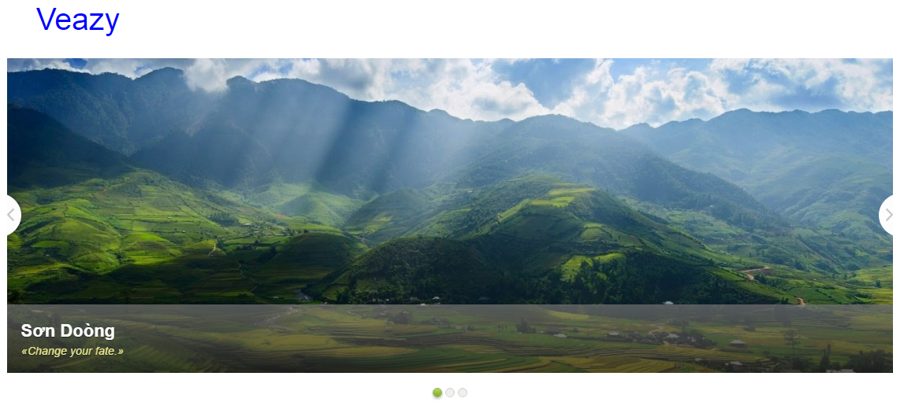

Figure 2. Homepage (1)

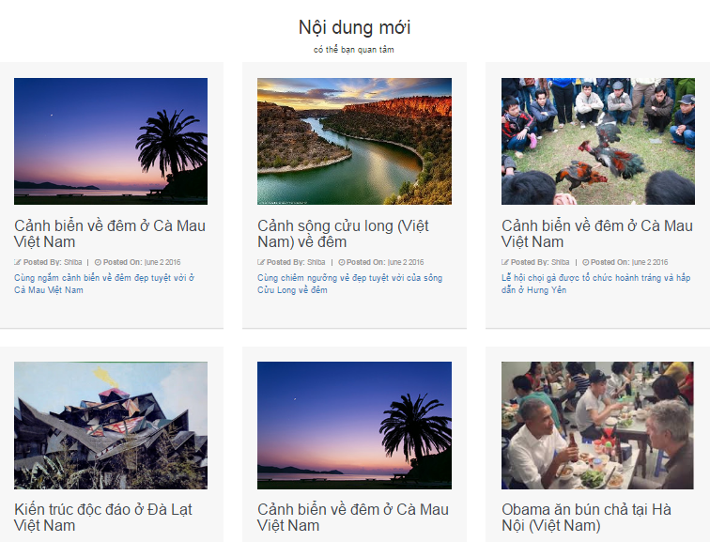

Figure 3. Homepage (1)

|  |  |  |  |  |  |  |  |
| --- | --- | --- | --- | --- | --- | --- | --- |
| **No** | **Field name** | **Format** | **Require** | **Mandatory** | **Min**  **length** | **Max**  **length** | **Description** |
| 1 | Veazy | Hyperlink | Click | N |  |  | User clicks to navigate to Homepage |
| 2 | Home | Hyperlink | Click | N |  |  | User clicks to navigate to Homepage |
| 3 | Courses | Dropdown | Select | N |  |  | User selects a course to navigate to Lesson List page |
| 4 | Test | Hyperlink | Click | N |  |  | User clicks to navigate to Test page |
| 5 | Reading | Hyperlink | Click | N |  |  | User clicks to navigate to Article List page |
| 6 | Login | Hyperlink | Click | N |  |  | User clicks to navigate to Login page |

Table 4. Homepage’s components

### Login

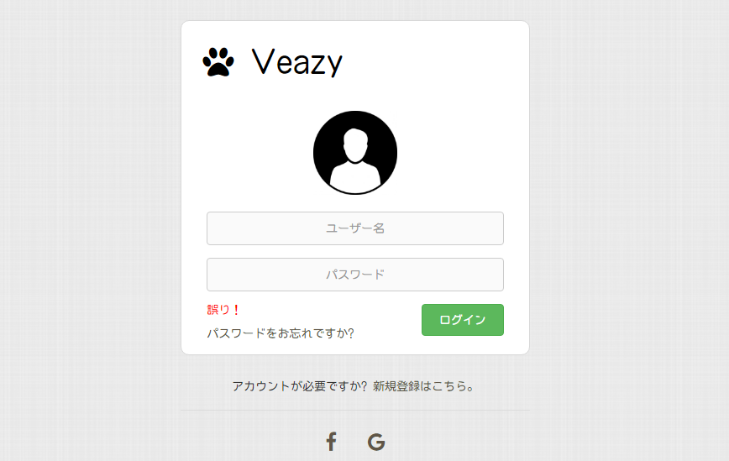

Figure 4. Login page

|  |  |  |  |  |  |  |  |
| --- | --- | --- | --- | --- | --- | --- | --- |
| **No** | **Field name** | **Format** | **Require** | **Mandatory** | **Min**  **length** | **Max**  **length** | **Description** |
| 1 | Veazy | Hyperlink | Click | N |  |  | User clicks to return to Homepage |
| 2 | Username | Text | Input | Y |  |  | User inputs username |
| 3 | Password | Password | Input | Y |  |  | User inputs password |
| 4 | Login | Button | Click | Y |  |  | User clicks to login and are redirected to Homepage (for learners) or Dashboard (for admin, content creators & content managers) |
| 5 | Forgot password? | Hyperlink | Click | N |  |  | User clicks to navigate to Recovering Password page |
| 6 | Register | Hyperlink | Click | N |  |  | User clicks to navigate to Register page |
| 7 | Facebook icon | Hyperlink | Click | N |  |  | User clicks to log in using Facebook account |
| 8 | Google icon | Hyperlink | Click | N |  |  | User clicks to login using Google account |

Table 5. Login page’s components

### Recovering Password

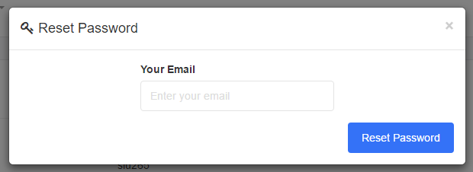

Figure 5. Recovering Password page

|  |  |  |  |  |  |  |  |
| --- | --- | --- | --- | --- | --- | --- | --- |
| **No** | **Field name** | **Format** | **Require** | **Mandatory** | **Min**  **length** | **Max**  **length** | **Description** |
| 1 | Email | Email | Input | Y |  |  | User inputs the email linked with current account |
| 2 | Reset password | Button | Click | Y |  |  | User click to recover the password |

Table 6. Recovering Password page’s components

### Register

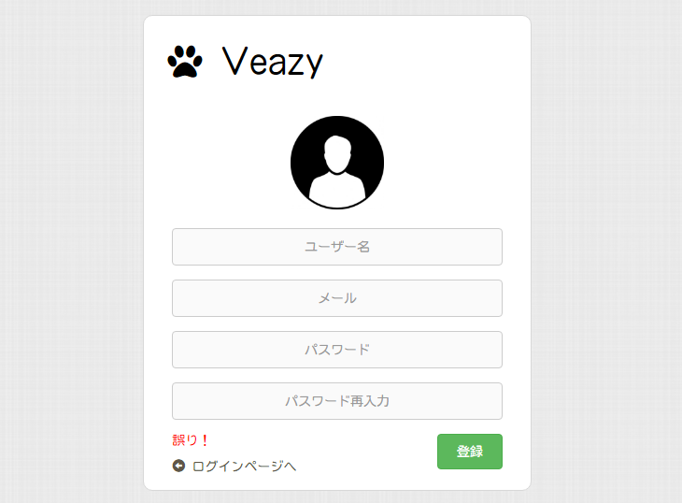

Figure 6. Register page

|  |  |  |  |  |  |  |  |
| --- | --- | --- | --- | --- | --- | --- | --- |
| **No** | **Field name** | **Format** | **Require** | **Mandatory** | **Min**  **length** | **Max**  **length** | **Description** |
| 1 | Veazy | Hyperlink | Click | N |  |  | User clicks to return to Homepage |
| 2 | Username | Text | Input | Y |  |  | User inputs username |
| 3 | Email | Email | Input | Y |  |  | User inputs email |
| 4 | Password | Password | Input | Y |  |  | User inputs password |
| 5 | Re-input password | Hyperlink | Input | Y |  |  | Users re-input password |
| 6 | Register | Button | Click | Y |  |  | User clicks to register new account |
| 8 | Return to login page | Hyperlink | Click | N |  |  | User clicks to return to Login page |

Table 7. Register page’s components

### Course

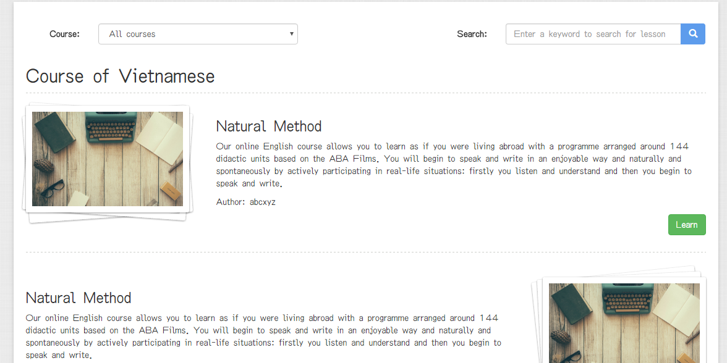

Figure 7. Course page

|  |  |  |  |  |  |  |  |
| --- | --- | --- | --- | --- | --- | --- | --- |
| **No** | **Field name** | **Format** | **Require** | **Mandatory** | **Min**  **length** | **Max**  **length** | **Description** |
| 1 | Course | Select box | Select |  |  |  | User clicks to select a course |
| 2 | Search | Text | Input |  |  |  | User inputs a keyword to search for lesson whose content contains that keyword |
| 3 | Learn | Button | Click |  |  |  | User clicks to view lesson content |

Table 8. Course page’s components

### Lesson Detail

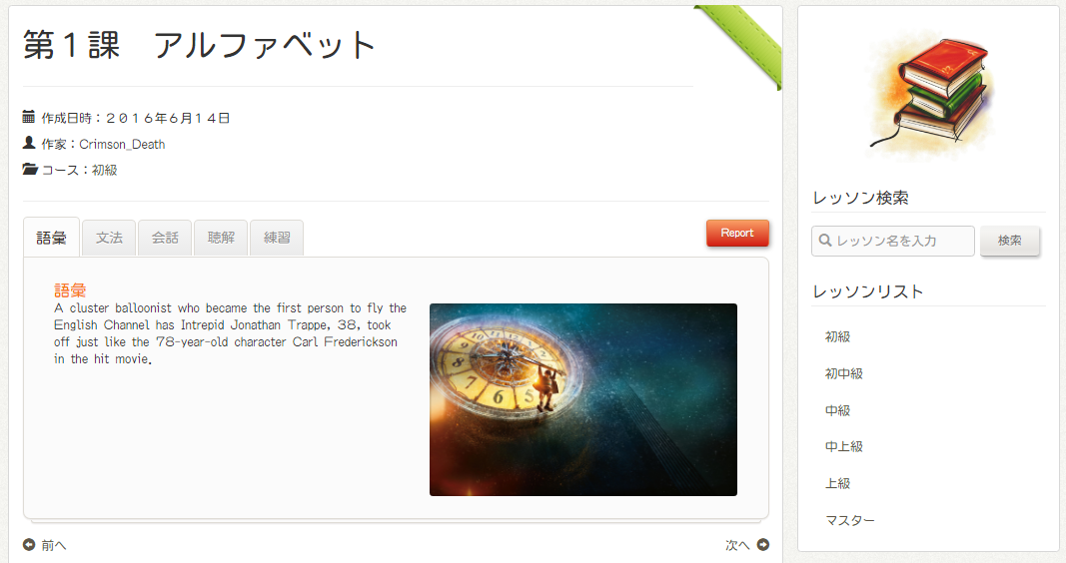

Figure 8. Lesson Detail

|  |  |  |  |  |  |  |  |
| --- | --- | --- | --- | --- | --- | --- | --- |
| **No** | **Field name** | **Format** | **Require** | **Mandatory** | **Min**  **length** | **Max**  **length** | **Description** |
| 1 | Course | Hyperlink | Click | N |  |  | User clicks to navigate to Lesson List page of the corresponding course |
| 2 | Vocabulary | Tab | Click | N |  |  | User clicks to display the vocabulary section |
| 3 | Grammar | Tab | Click | N |  |  | User clicks to display the grammar section |
| 4 | Conversation | Tab | Click | N |  |  | User clicks to display the conversation section |
| 5 | Practice | Tab | Click | N |  |  | User clicks to display the practice section |
| 6 | Report | Button | Click | N |  |  | User clicks to report lesson content |
| 7 | Previous lesson | Hyperlink | Click | N |  |  | User clicks to display content of the lesson before |
| 8 | Next lesson | Hyperlink | Click | N |  |  | User clicks to display content of the lesson after |
| 9 | Search lesson | Text | Input | N |  |  | User inputs a keyword and press Enter key to display lessons which contain the keyword in their content |
| 10 | Search lesson | Button | Click | N |  |  | User clicks to search lesson with input keyword |

Table 9. Lesson Detail page’s components

### Test

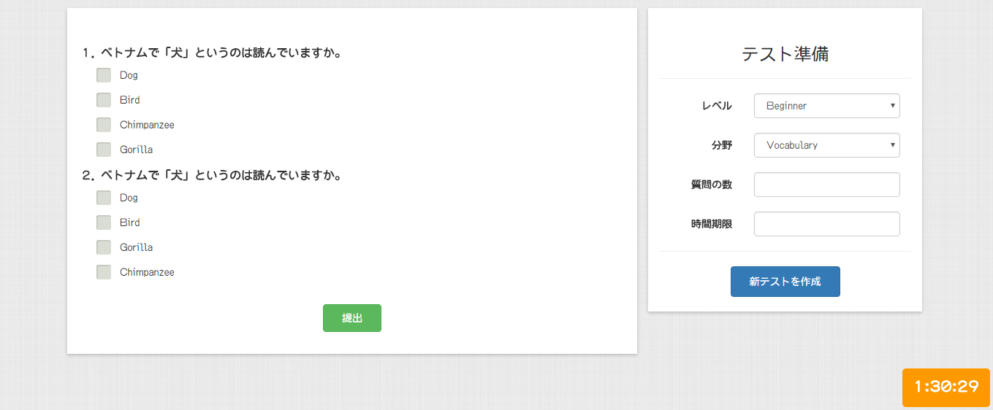

Figure 9. Test page

|  |  |  |  |  |  |  |  |
| --- | --- | --- | --- | --- | --- | --- | --- |
| **No** | **Field name** | **Format** | **Require** | **Mandatory** | **Min**  **length** | **Max**  **length** | **Description** |
| 1 | Level | Select box | Select | Y |  |  | User selects difficulty level |
| 2 | Skill | Select box | Select | Y |  |  | User selects the skill to be tested |
| 3 | Number of question | Number | Input | Y | 20 |  | User inputs number of questions test |
| 4 | Start test | Button | Click | Y |  |  | User clicks to generate a new test and start doing |
| 5 | Answer | Radio button | Click | Y |  |  | User clicks to choose the correct answer |
| 6 | Submit | Button | Click | Y |  |  | User clicks to submit the answer and display results |

Table 10. Test page’s components

### Article List

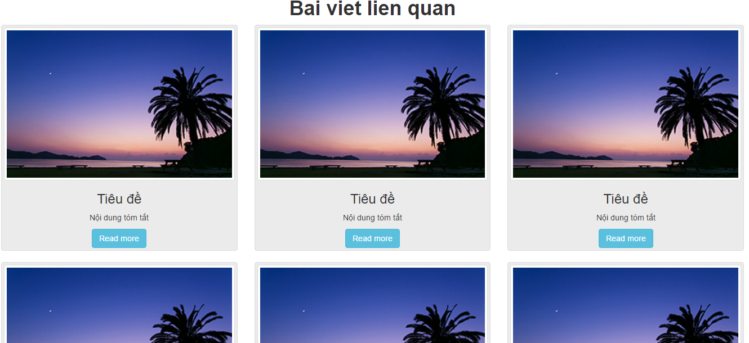

Figure 10. Article List page

|  |  |  |  |  |  |  |  |
| --- | --- | --- | --- | --- | --- | --- | --- |
| **No** | **Field name** | **Format** | **Require** | **Mandatory** | **Min**  **length** | **Max**  **length** | **Description** |
| 1 | Read more | Button | Click | N |  |  | User clicks to navigate to Article Detail page |

Table 11. Article List page’s components

### Article Detail

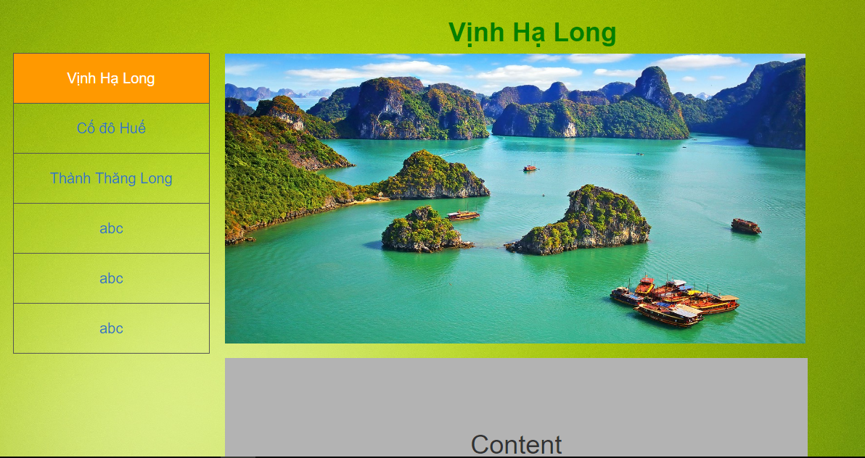

Figure 11. Article Detail page

|  |  |  |  |  |  |  |  |
| --- | --- | --- | --- | --- | --- | --- | --- |
| **No** | **Field name** | **Format** | **Require** | **Mandatory** | **Min**  **length** | **Max**  **length** | **Description** |
| 1 | Article name | Hyperlink | Click | N |  |  | User clicks to display content of the selected article |

Table 12. Article Detail page’s components

## Logged-in user

### User Profile

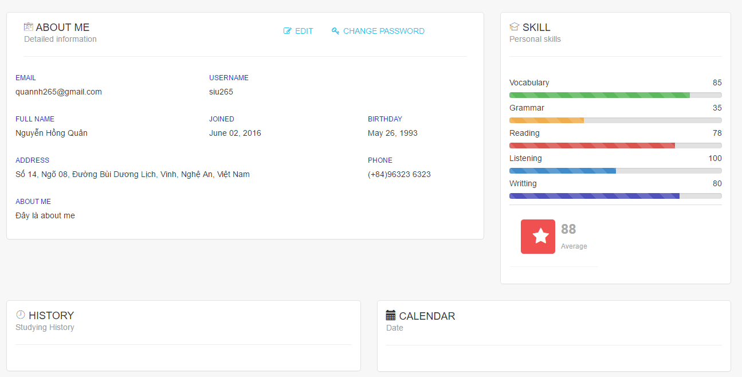

Figure 12. User Profile page

|  |  |  |  |  |  |  |  |
| --- | --- | --- | --- | --- | --- | --- | --- |
| **No** | **Field name** | **Format** | **Require** | **Mandatory** | **Min**  **length** | **Max**  **length** | **Description** |
| 1 | Edit | Hyperlink | Click | N |  |  | User clicks to enable editing detailed information |
| 2 | Change password | Hyperlink | Click | N |  |  | User clicks to enable changing password |

Table 13. User Profile page’s components

### Test Statistics

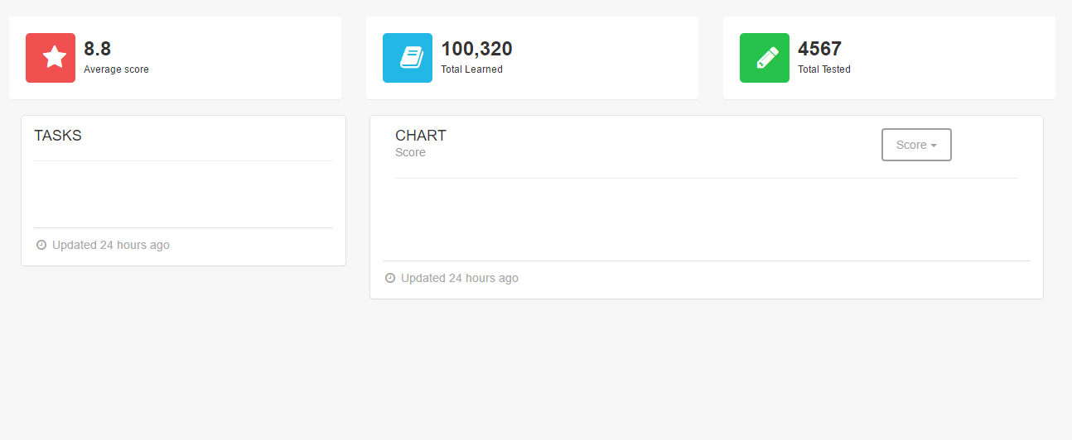

Figure 13. Test Statistics page

|  |  |  |  |  |  |  |  |
| --- | --- | --- | --- | --- | --- | --- | --- |
| **No** | **Field name** | **Format** | **Require** | **Mandatory** | **Min**  **length** | **Max**  **length** | **Description** |
| 1 | Score | Dropdown box | Click | N |  |  | User clicks to change the type of statistics to be displayed |

Table 14. Test Statistics page’s components

## Content creator

### Content Creator Dashboard

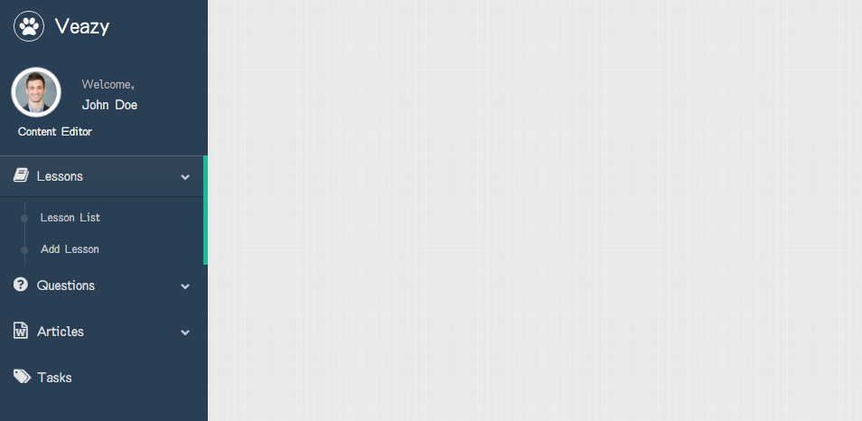

Figure 14. Content Creator Dashboard page

|  |  |  |  |  |  |  |  |
| --- | --- | --- | --- | --- | --- | --- | --- |
| **No** | **Field name** | **Format** | **Require** | **Mandatory** | **Min**  **length** | **Max**  **length** | **Description** |
| 1 | Lessons | Hyperlink | Click | N |  |  | User clicks to display menu involved with lesson management |
| 2 | Lesson List | Hyperlink | Click | N |  |  | User clicks to navigate to Lesson List page (for content creator) |
| 3 | Add Lesson | Hyperlink | Click | N |  |  | User clicks to navigate to Adding Lesson page |
| 4 | Question | Hyperlink | Click | N |  |  | User clicks to display menu involved with question management |
| 5 | Question List | Hyperlink | Click | N |  |  | User clicks to navigate to Question List page (for content creator) |
| 6 | Add Question | Hyperlink | Click | N |  |  | Users clicks to navigate to Adding Question page |
| 7 | Articles | Hyperlink | Click | N |  |  | User clicks to display menu involved with article management |
| 8 | Article List | Hyperlink | Click | N |  |  | User clicks to navigate to Article List page |
| 9 | Add Article | Hyperlink | Click | N |  |  | User clicks to navigate to Adding Article page |
| 10 | Tasks | Hyperlink | Click | N |  |  | User clicks to navigate to Tasks page |

Figure 15. Content Creator Dashboard's components

### Lesson List

### Lesson Detail

### Adding Lesson

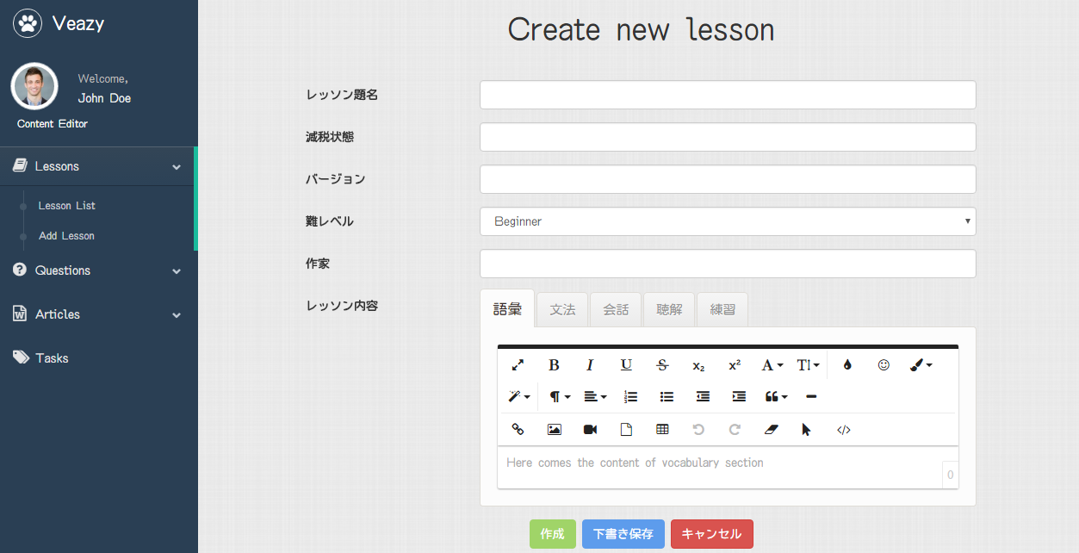

Figure 16. Adding Lesson page

|  |  |  |  |  |  |  |  |
| --- | --- | --- | --- | --- | --- | --- | --- |
| **No** | **Field name** | **Format** | **Require** | **Mandatory** | **Min**  **length** | **Max**  **length** | **Description** |
| 1 | Title | Text | Input | Y |  |  | User inputs lesson title |
| 2 | State | Text |  | Y |  |  | Displaying current state of lesson (auto-generated) |
| 3 | Version | Text |  | Y |  |  | Displaying version number of lesson (auto-generated) |
| 4 | Level | Dropdown box |  | Y |  |  | User selects difficulty level of lesson |
| 5 | Author | Text |  | Y |  |  | Display username of author (auto-generated) |
| 6 | Vocabulary | Hyperlink | Click | Y |  |  | User clicks to display textarea in order to input content of vocabulary section |
| Text | Input | Y |  |  | User inputs the content of vocabulary section |
| 7 | Grammar | Hyperlink | Click | Y |  |  | User clicks to display textarea in order to input content of grammar section |
| Text | Input | Y |  |  | User inputs the content of grammar section |
| 8 | Conversation | Hyperlink | Click | Y |  |  | User clicks to display textarea in order to input content of conversation section |
| Text | Input | Y |  |  | User inputs the content of conversation section |
| 9 | Listening | Hyperlink | Input | Y |  |  | User clicks to display textarea in order to input content of listening section |
| Text | Input | Y |  |  | User inputs the content of listening section |
| 10 | Practice | Hyperlink | Click | Y |  |  | User clicks to display textarea in order to input content of practice section |
| Text | Input | Y |  |  | User inputs content of practice section |
| 11 | Create | Button | Click | Y |  |  | User clicks to submit and create new lesson |
| 12 | Save draft | Button | Click | N |  |  | User clicks to save content as draft so that it can be re-opened next time |

Table 15. Adding Lesson page’s components

### Editing Lesson

### Question List

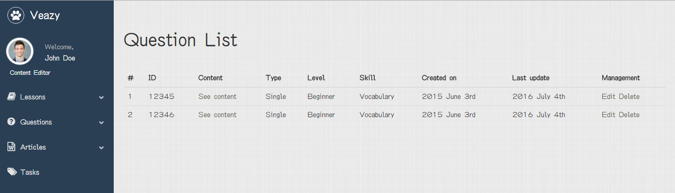

Figure 18. Question List

|  |  |  |  |  |  |  |  |
| --- | --- | --- | --- | --- | --- | --- | --- |
| **No** | **Field name** | **Format** | **Require** | **Mandatory** | **Min**  **length** | **Max**  **length** | **Description** |
| 1 | See content | Hyperlink | Click | N |  |  | User clicks to display question content |
| 2 | Edit | Button | Click | N |  |  | User clicks to edit question content |
| 3 | Delete | Button | Click | N |  |  | User clicks to delete the question |

Table 17. Question List page’s components

### Question Detail

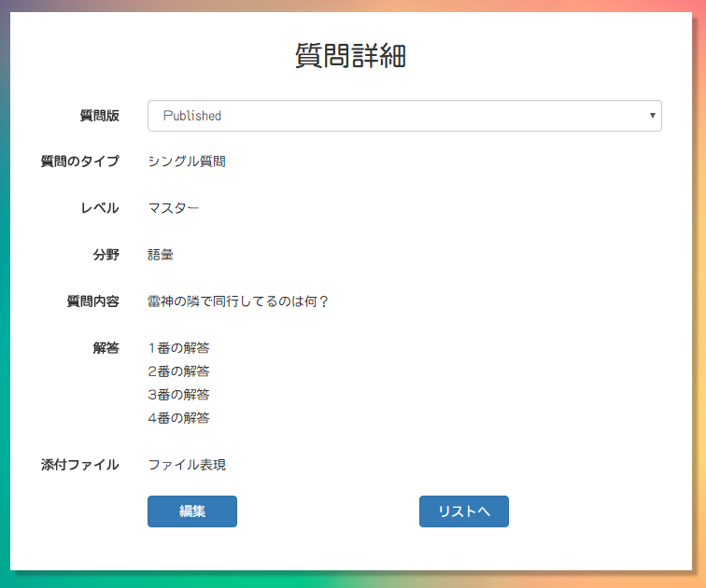

Figure 19. Question Detail

|  |  |  |  |  |  |  |  |
| --- | --- | --- | --- | --- | --- | --- | --- |
| **No** | **Field name** | **Format** | **Require** | **Mandatory** | **Min**  **length** | **Max**  **length** | **Description** |
| 1 | Edit | Button | Click | N |  |  | User clicks to edit question content |
| 2 | Back to list | Button | Click | N |  |  | User clicks to return to Question List page |

### Adding question

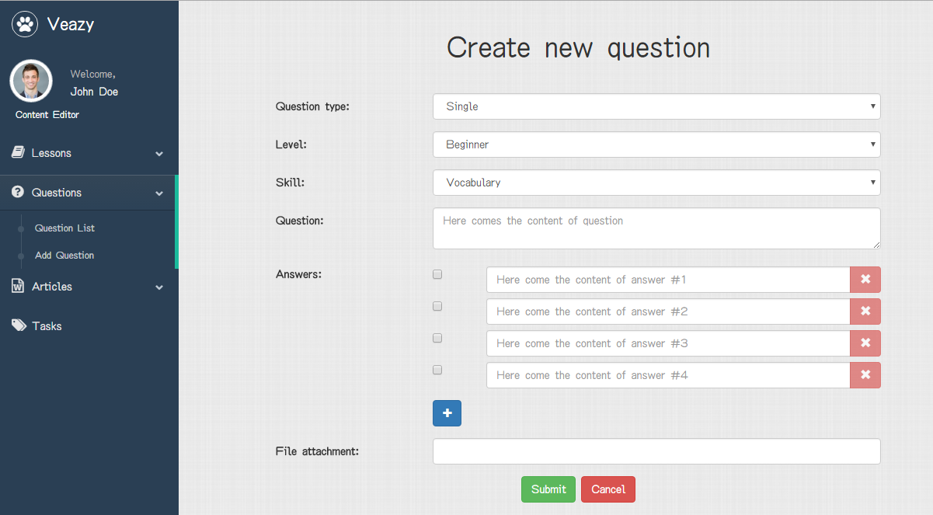

Figure 20. Adding Question page (single question)

|  |  |  |  |  |  |  |  |
| --- | --- | --- | --- | --- | --- | --- | --- |
| **No** | **Field name** | **Format** | **Require** | **Mandatory** | **Min**  **length** | **Max**  **length** | **Description** |
| 1 | Question type | Select box | Select | Y |  |  | User selects whether the question is single type or group type |
| 2 | Level | Select box | Select | Y |  |  | User selects difficulty level of question |
| 3 | Skill | Select box | Select | Y |  |  | User selects the skill of question |
| 4 | Question content | Text | Input | Y |  |  | User inputs the question content |
| 5 | Correct answer | Radio button | Click | Y |  |  | User clicks to decide the correct answer |
| 6 | Answer | Text | Input | Y |  |  | User inputs answer content |
| 7 | X | Button | Click | N |  |  | User click to remove the corresponding answer |
| 8 | Add answer | Button | Click | N |  |  | User clicks to add one more answer |
| 9 | File attachment | File | Upload | N |  |  | User clicks to choose file and upload |
| 10 | Create | Button | Click | Y |  |  | User clicks the to submit the content and create new question |
| 11 | Cancel | Button | Click | N |  |  | User clicks to return to Question List page |

Table 18. Adding Question page’s components (1)

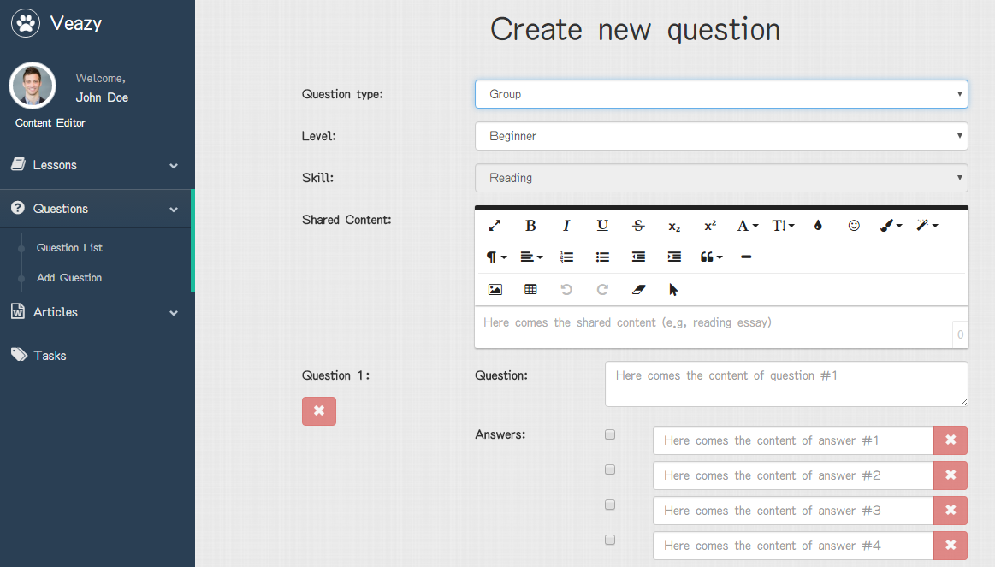

Figure 21. Adding Question page (group question) (1)

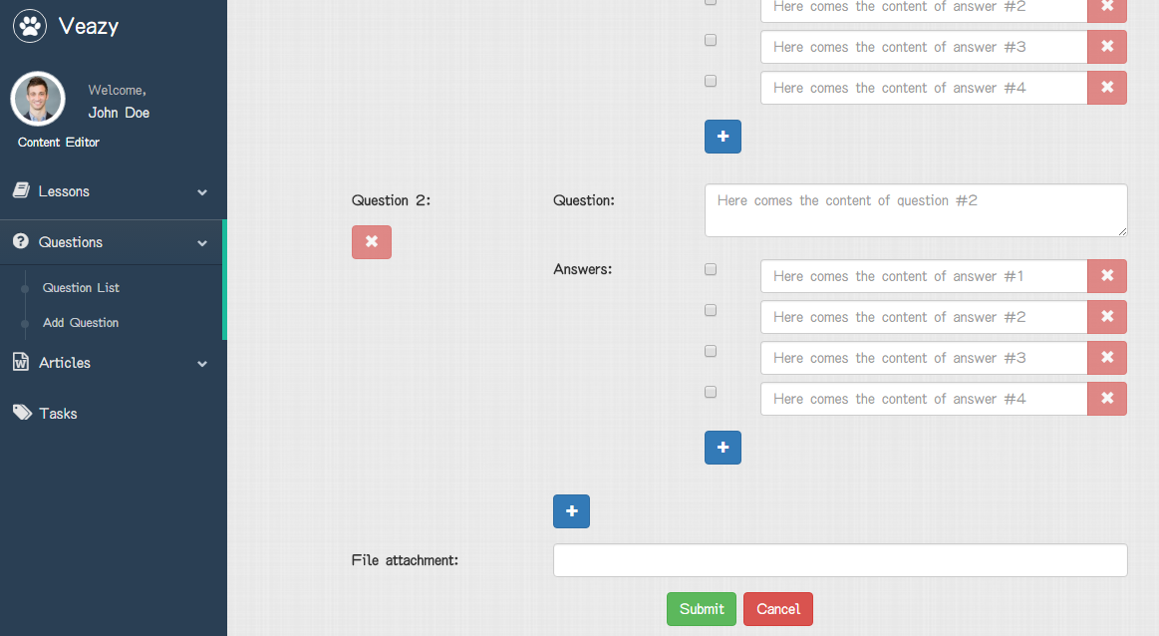

Figure 22. Adding Question page (group question) (2)

|  |  |  |  |  |  |  |  |
| --- | --- | --- | --- | --- | --- | --- | --- |
| **No** | **Field name** | **Format** | **Require** | **Mandatory** | **Min**  **length** | **Max**  **length** | **Description** |
| 1 | Question type | Select box | Select | Y |  |  | User selects the type of question to be added |
| 2 | Level | Select box | Select | Y |  |  | User selects difficulty level of question |
| 3 | Skill | Select box | Select | Y |  |  | User selects the skill of question |
| 4 | Shared content | Text | Input | Y |  |  | User inputs the shared content used by all questions |
| 5 | Question | Text | Input | Y |  |  | User inputs content of a single question in group |
| 6 | X | Button | Click | N |  |  | User clicks to remove the corresponding question in group |
| 7 | Correct answer | Check box | Click | Y |  |  | User clicks to decide the correct answer(s) |
| 8 | Answer | Text | Input | Y |  |  | User inputs answer content of each question |
| 9 | X | Button | Click | Y |  |  | User clicks to remove the corresponding answer |
| 10 | Add | Button | Click | N |  |  | User clicks to add more question to the group |
| 11 | File attachment | File | Upload | N |  |  | User clicks to choose file and upload |
| 12 | Submit | Button | Click | Y |  |  | User clicks to submit the group question |
| 13 | Cancel | Button | Click | Y |  |  | User clicks to cancel adding and return to Questions List page |

Table 19. Adding Question page’s components (2)

### Editing Question

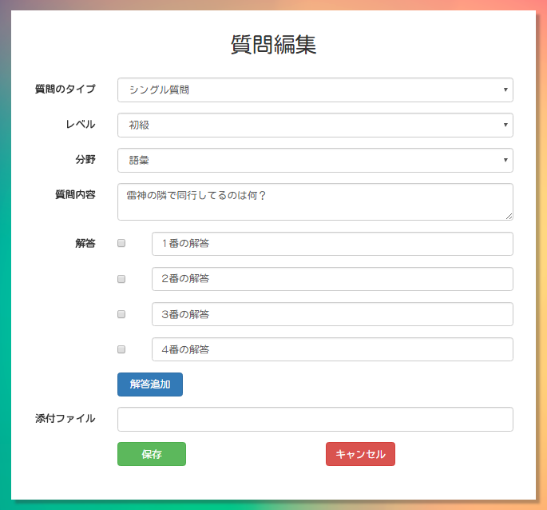

Figure 23. Editing Question page (single question)

|  |  |  |  |  |  |  |  |
| --- | --- | --- | --- | --- | --- | --- | --- |
| **No** | **Field name** | **Format** | **Require** | **Mandatory** | **Min**  **length** | **Max**  **length** | **Description** |
| 1 | Question type | Select box | Select | Y |  |  | User selects the type of question to be edited |
| 2 | Level | Select box | Select | Y |  |  | User selects difficulty level of the question |
| 3 | Skill | Select box | Select | Y |  |  | User selects the skill of question |
| 4 | Question detail | Text | Input | Y |  |  | User inputs question content |
| 5 | Correct answer | Radio button | Click | Y |  |  | User clicks to decide the correct answer(s) |
| 6 | Answer | Text | Input | Y |  |  | User inputs contents of selectable answers of a question |
| 7 | Add answer | Button | Click | N |  |  | User clicks button to add more selectable answers of the question. |
| 8 | File attachment | File | Upload | N |  |  | User clicks to choose file and upload |
| 9 | Create | Button | Click | Y |  |  | User clicks to submit the question content |
| 10 | Cancel | Button | Click | N |  |  | User clicks to go back to Questions List page |

Table 20. Editing Question page’s components (1)

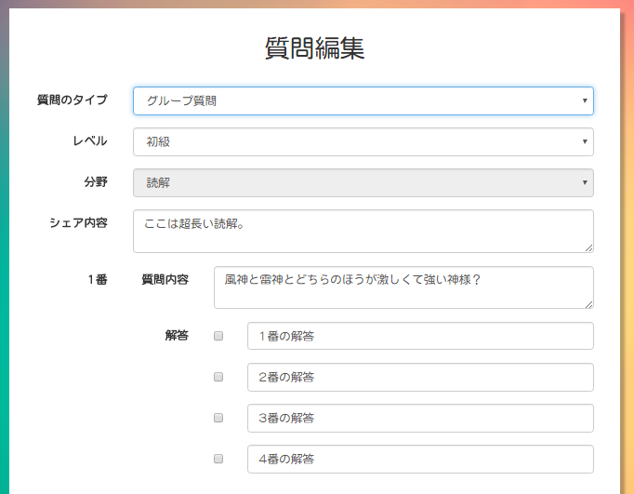

Figure 24. Editing Question Page (group question) (1)

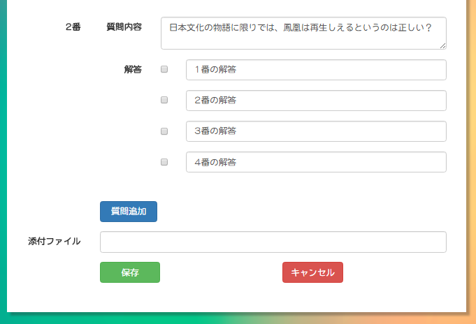

Figure 25. Editing Question page (group question) (2)

|  |  |  |  |  |  |  |  |
| --- | --- | --- | --- | --- | --- | --- | --- |
| **No** | **Field name** | **Format** | **Require** | **Mandatory** | **Min**  **length** | **Max**  **length** | **Description** |
| 1 | Question type | Select box | Select | Y |  |  | User selects the type of question to be edited |
| 2 | Level | Select box | Select | Y |  |  | User selects difficulty level of question |
| 3 | Skill | Select box | Select | Y |  |  | User selects the skill to be tested |
| 4 | Shared content | Text | Input | Y |  |  | User inputs the shared content used by all questions |
| 5 | Question content | Text | Input | Y |  |  | User inputs content of a single question in group |
| 6 | Correct answer | Check box | Click | Y |  |  | User clicks to decide the correct answer(s) |
| 7 | Answer | Text | Input | Y |  |  | User inputs answer content |
| 8 | Add | Button | Click | N |  |  | User clicks to add more question to the group |
| 9 | File attachment | File | Upload | N |  |  | User clicks to choose file and upload |
| 10 | Submit | Button | Click | Y |  |  | User clicks to submit group question |
| 11 | Cancel | Button | Click | Y |  |  | User clicks to cancel adding and return to Question List page |

Table 21. Editing Question page’s components (group question)

## Content manager

## Admin

### Admin Dashboard

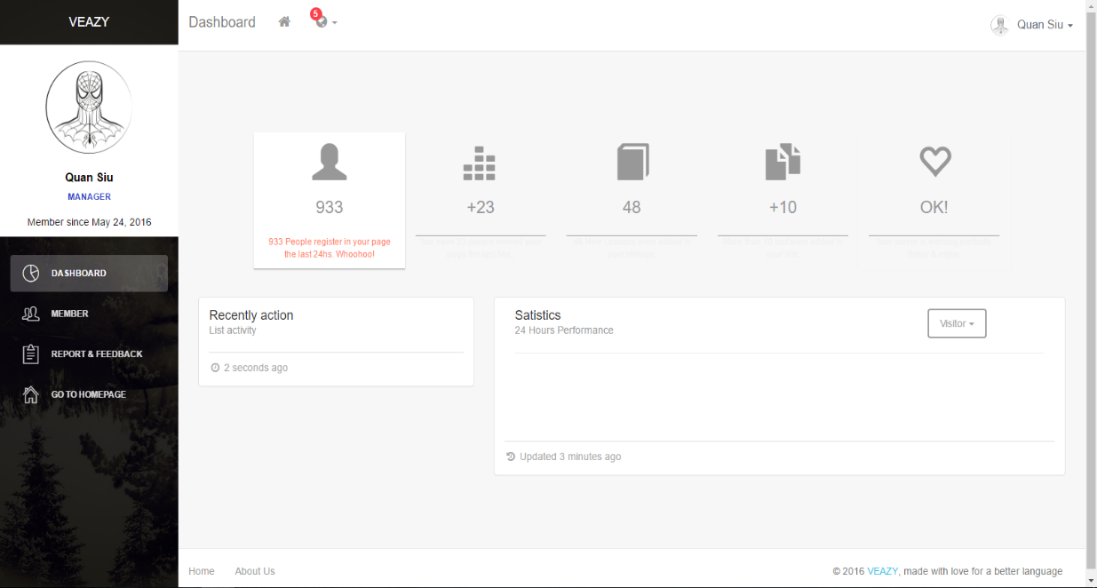

Figure 26. Admin Dashboard page

|  |  |  |  |  |  |  |  |
| --- | --- | --- | --- | --- | --- | --- | --- |
| **No** | **Field name** | **Format** | **Require** | **Mandatory** | **Min**  **length** | **Max**  **length** | **Description** |
| 1 | Member | Hyperlink | Click | N |  |  | User clicks to navigate to Member List page |
| 2 | Report & Feedback | Hyperlink | Click | N |  |  | User clicks to display list of reports & feedbacks |

Table 22. Admin Dashboard page’s components

### Member List

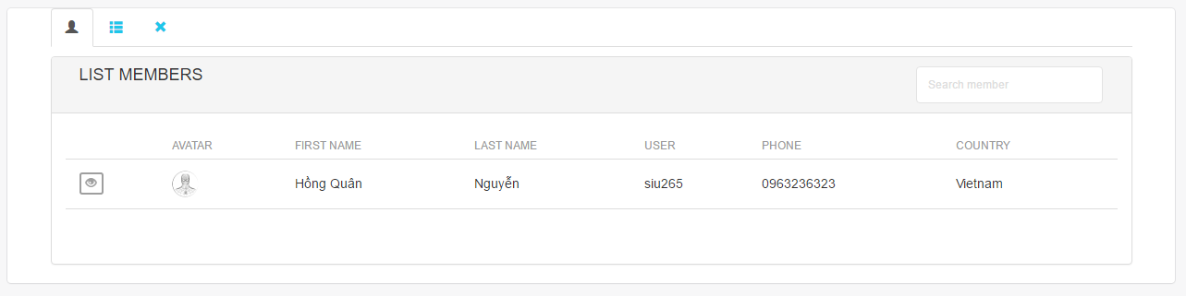

Figure 27. Member List page

|  |  |  |  |  |  |  |  |
| --- | --- | --- | --- | --- | --- | --- | --- |
| **No** | **Field name** | **Format** | **Require** | **Mandatory** | **Min**  **length** | **Max**  **length** | **Description** |
| 1 | Member list | Tab | Click | N |  |  | User clicks to display member list |
| 2 | Member list by role | Tab | Click | N |  |  | User clicks to display member list with respective roles |
| 3 | Banned member list | Tab | Click | N |  |  | User clicks to display banned member list |
| 4 | View detail | Button | Click | N |  |  | User clicks to display detailed information of members |
| 5 | Search member | Text | Input | N |  |  | User inputs a keyword to search |

Table 23. Member List page’s components

### Report List

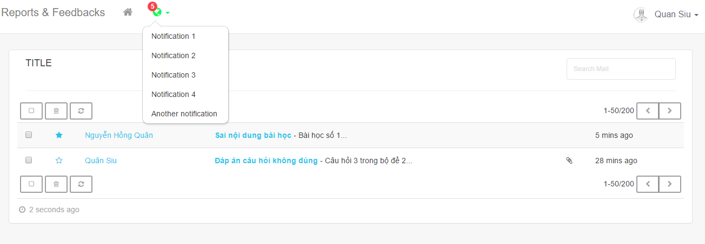

Figure 28. Report List page

|  |  |  |  |  |  |  |  |
| --- | --- | --- | --- | --- | --- | --- | --- |
| **No** | **Field name** | **Format** | **Require** | **Mandatory** | **Min**  **length** | **Max**  **length** | **Description** |
| 1 | Select all | Check box | Click | N |  |  | User clicks to select all reports |
| 2 | Delete | Button | Click | N |  |  | User clicks to delete selected reports |
| 3 | Reload | Button | Click | N |  |  | User clicks to reload list of reports |
| 4 | Right | Button | Click | N |  |  | User clicks to navigate to the next page |
| 5 | Left | Button | Click | N |  |  | User clicks to navigate to the previous page |

Table 24. Report List page’s components

# Other considerations

**N/A**